Documentation of Medical Student Clinical Patient Encounters
FSU College of Medicine
E*Value System for Clerkships
Student Responsibility:
While seeing patients, write on paper so you can enter the patient data later on the E*Value system using the web interface or you can use Safari on your iPod or Smart Phone to access the E*Value website if you have a connection [Wireless or 3/4G]. The web site is mobile formatted. Simply create a shortcut to the site on your device.
Documentation Instructions
Go to the E*Value web-site under My Resources from the main CoM website and sign in using your FSU College of Medicine sign on. Choose FSU M3 and M4 Clerkships. Then click on PxDx and select Add New PxDx Records.

MAIN

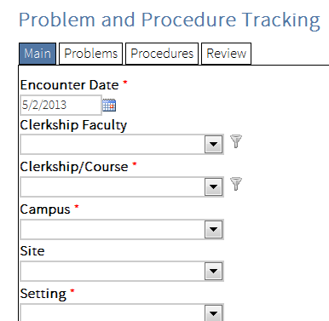
Encounter Date: Make sure the Date you enter is the date you actually saw the patient. System will not allow post-dating greater than 8 days, so record in a timely manner.
Clerkship Faculty: If your clerkship faculty member is not listed, contact your clinical coordinator immediately. Use the clerkship director’s name in the interim.
Clerkship/Course: Be sure to pick the correct clerkship.
Campus: select your regional campus.
Site: Use if not in the same community as regional campus, like Immokalee.
Setting: Type of facility
Age: Choose the correct age range.
Gender:
Ethnicity:
Patient New to You?: Yes or No. If this is the first time YOU, personally (not the clinic), have seen this patient, select Yes under Patient is New to Me?
Zip Code: The zip code of the patient’s home, where they live or are staying. Enter 99999 if the patient is homeless or you do not know.
Visit Level of Care: Select the Visit Level of Care that indicates most accurately your interaction and involvement with the patient during this encounter.
- Minimal: Min. Pt. contact – Only record clinically significant encounters. Do not record observations unless you see a procedure. You will not use this level much in 3rd year except for observing a procedure.
- Moderate: Hx and/or PE - The student performs either a problem focused or complete Hx and/or PE but has no role in the diagnosis or treatment of the patient.
- Full: Hx and PE + (DDx and/or Tx) - The student performs a history and physical exam and is involved in the diagnosis and treatment of the patients under supervision of the resident or attending physician. This includes ongoing management of hospitalized patients.

Type of Visit: Type of Visit records the primary reason that the patient has come to the doctor’s office or that the physician initiated the visit. See the list at right. For annual physicals use Periodic Preventive Care. Use Physical Exam NOS to record an encounter that occurs to perform physicals for sports, insurance or other physicals that require a form to be completed. Chronic Dx Management is for visits to manage diseases like Diabetes and Hypertension and refill prescriptions for these established conditions.
Type of Patient: Patients seen in your preceptor’s office are Regular Patients.

Notes: Use Notes to remind yourself of some interesting aspect of the encounter or to specify a diagnosis when you had to select Other … from the problem list because the real problem was not there.

Problems

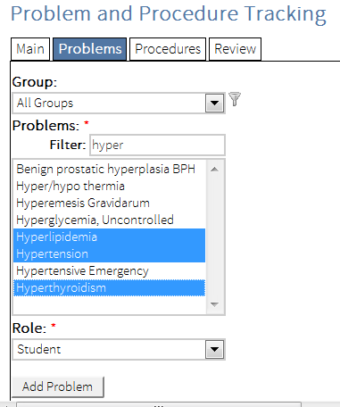
Problems include any or all of the final diagnoses, (Assessment section of SOAPnote) or major symptom if no diagnoses is determined, which were addressed at this visit or considered in the treatment for this visit. You can add as many problems as were addressed.

The Filter will drop down all matches to the first few letters you type. It is unnecessary to use the Groups except as a method of finding a diagnosis that might be called something other than what you are looking for. Hold down CTRL to select more than one problem.
Click Add Problem to add to the list.

Clerkship Specific Problems Groups: for each clerkship, there is a list of specific problems monitored by the education and clerkship directors. Look at these groups. Several new problems have been added to the list this year.

If the problem was not on the list, there are “Other xxx problems” for every category/group. Use these, but only if you cannot find something that “fits.” Suggestions: for Well Child, Physical Exam, or Periodic Preventive Care visits types when the patient is well/not ill, use the problem Health Maintenance.

You can Save at this point or go on and add Procedures

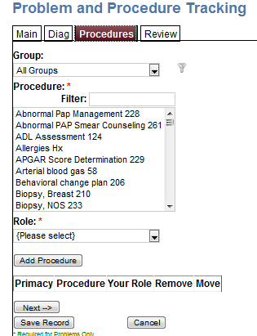
Procedures

There is a long list of procedures to pick from. There are many more than last year. You can add none, or multiple procedures for any encounter. If you do not select a Procedure Group, all the available procedures will come up under Procedures. If you pick a category like Evaluation and Management, a much shorter list of procedures (just the ones in that category) will show up. You can search using the Filter for any part of a word. You must pick both the procedure and the Your role in the procedure (Observed, Assisted or Performed) and Add Procedure. You may add multiple procedures. Notice that the procedures for many of the History and Physical Exams used in M1 and M2 have gone away.

Clerkship Specific Procedures Groups: Like the problems, for each clerkship there are selected procedures which are monitored by the education and clerkship directors. Look at these groups to make sure you have met the requirement for these that is stated in the syllabus during the clerkship.

Review

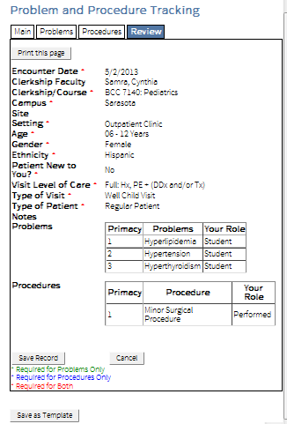
You can see the entire record to check and make sure it is accurate and you didn’t forget anything that you did before you save the encounter.

Click Save Record.

On the PDA, the new encounter is listed as ready to sync. You have to get on a wireless somewhere and click Sync to transfer these encounters to the website.

Let Becky Shiveler 645-1196, rebecca.shiveler@med.fsu.edu know immediately if you lose any patients. Leave a voice message or send an email.

Editing Previous Patient Encounters

You can edit any old patient encounter under PxDx Review/Edit on the web interface. Enter a start date and an end date, then click Next.

At the bottom of the page, encounters in that date range will be listed. Find the patient you need to edit and click the edit button next to the encounter. If you happen to duplicate a patient accidentally, you can delete encounters in this view, as well.

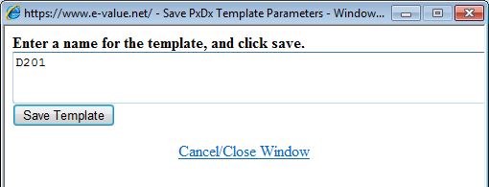
Using the Templates to Save Time

E*Value allows you to save a completed form as a template to save time entering those items that don’t change like the Site, Course, Campus, and so forth.

To create a template that has the Course, Campus and Setting, fill these out on a new encounter under Main, then at the bottom of the screen, click the button Save as Template and give the template a name like FM Clerkship. Then Save Template again.

Now when you create a new encounter, at the bottom of the screen is a dropdown of Saved Templates. You can pick FM Clerkship , hit Load Selected Template, and the Main form will fill out those fields. Make sure you enter the correct date of the encounter.

Unfortunately, the date saves as well, so you have to change the date, if incorrect, each time you use the template unless you create a new template each day you are seeing patients. It is likely best to create a new template with your first encounter of a morning and use it the entire day, then create a new one the next day.

Test Patient: Enter at least one test patient during training session. Use Supervisor: your RC dean.
“62 year old Hispanic man comes in to your preceptor’s clinic to get his pain medications refilled. He has arthritis of the shoulders and lower back pain. The pain medicine is for the arthritis for which you review with him his symptoms. While he is there you also discuss his smoking habit, and he complains of pain in his mouth. Upon examination (HEENT), you notice an abscessed tooth. Your preceptor refers the patient to a dentist.”

